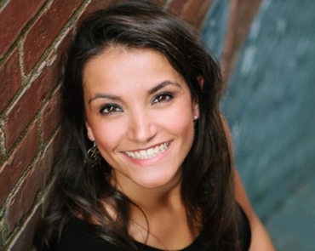
Maria Palombo soprano

mkp333@nyu.edu www.mariapalombo.com (919) 667-3058

Stage Experience *=scene
Ensemble Candide Philadelphia Orchestra 2019
Caroler/Townsperson A Christmas Carol McCarter Theatre 2018
Soprano chorus Tosca Philadelphia Orchestra 2018
Soprano chorus L’amore dei tre re New York City Opera 2018
Soprano chorus Pygmalion (Rameau) New York City Opera 2018
Cinderella Finding Cinderella (MT and Opera) Opera 691 2016
Torta Gwentrob Night Caps (Penthouse Suite) Opera Theater of Pittsburgh 2016
Lili Vanessi (cover) Kiss Me Kate Opera Theater of Pittsburgh 2016
Inkeeper/Ensemble Kiss Me Kate Opera Theater of Pittsburgh 2016
Monica The Medium New York University 2016
Zweite Dame Die Zauberflöte New York Lyric Opera 2015
Giulietta* I Capuleti e i Montecchi New York University 2015
Cendrillon Cendrillon New York University 2015
Lauretta Gianni Schicchi UNC Chapel Hill 2014
Lauretta Buoso’s Ghost (Michael Ching) UNC Chapel Hill 2014
Soprano chorus La bohème North Carolina Opera 2014
Servilia La clemenza di Tito UNC Chapel Hill 2013
Euridice* Orfeo ed Euridice (Gluck) UNC Chapel Hill 2013
La Soeur Jumelle* Les Malheurs d’Orphée (Milhaud) UNC Chapel Hill 2013
Zémire * Zémire et Azor (Gretry) UNC Chapel Hill 2013
Zweite Dame Die Zauberflöte Amalfi Coast Festival 2012
Mary Highway 1, USA (W.G. Still) UNC Chapel Hill 2012
The Mother Amahl and the Night Visitors Watts St Church (NC) 2011

Concert
Soprano Soloist Gloria (Vivaldi) Nassau Church, Princeton 2019
Soprano Soloist Melodious Accord (Alice Parker) Nassau Church, Princeton 2018
Soprano Soloist Coronation Mass (Mozart) Nassau Church, Princeton 2018
Benefit Concert Broadway Theater of Pitman Pitman, NJ 2017
Soprano Soloist Rejoice in the Lamb (Britten) Trinity Episcopal, Princeton 2017
Soprano Soloist Outreach/Education North Carolina Opera 2014-15

Education & Training Programs
New York University Master of Music (Voice) New York, NY 2016
Certificate in Vocal Pedagogy
UNC Chapel Hill Bachelor of Music Chapel Hill, NC 2014
Bachelor of Art (Drama)
Opera Theater of Pittsburgh YAP Pittsburgh, PA 2016
Oberlin in Italy Emerging Artist Arezzo, Italy 2012
Amalfi Coast Festival Festival Singer Maiori, Italy 2012

Teachers Coaches Directors Conductors
Dr. Kathy Price Christopher Zemliauskas Dallett Norris Andrew Altenbach
Jeremy Aye Grant Wenaus Richard Stafford Dr. Joe Miller
Dianna Heldman Dr. Louise Toppin Adam Immerwahr Thomas Jaber

